Repeated Measures ANOVA
A counseling Psychologist is studying the impact of three different therapeutic techniques on client self-esteem. Five clients participated in each of the following three conditions. 1) Cognitive Behavioral Therapy (CBT), 2) Mindfulness-Based Therapy (MBT) and 3) Supportive Counseling (SC). The client receives on month of each type of therapy at the end of each month, they complete a standardized self-esteem questionnaire (0 – 30, higher scores == higher self-esteem). Client scores for each treatment are listed below:
Client | CBT | MBT | SC
1 | 24 | 22 | 18
2 | 26 | 25 | 20
3 | 21 | 19 | 16
4 | 27 | 24 | 21
5 | 25 | 23 | 19

Research question: Is there a significant difference between therapy techniques?
- Fill in the table with each group’s mean, within treatments sum of squares, (SS_{W}), sum of squares between groups participants (SS_{B}), degrees of freedom
Client | CBT | MBT | SC | Client Means (M_{P}) | (M_{P} – M_{G})²
1 | 24 | 22 | 18 | 21.33 | 0.45
2 | 26 | 25 | 20 | 23.67 | 2.79
3 | 21 | 19 | 16 | 18.67 | 11.09
4 | 27 | 24 | 21 | 24.00 | 4.00
5 | 25 | 23 | 19 | 22.33 | 0.11
Condition Means | 24.6 | 22.6 | 18.8 | M_{G} = ___22.0_____ | SS_{B} = __18.44___ × k  SS_{B} = __55.32____
SS (within treatments) | 21.2 | 21.2 | 14.8
df (Within Treatments) | 4 | 4 | 4

- Calculate SS_{T}, SS_{B}, and SS_{W}
SS_{T} = 144
SS_{B} = 55.32
SS_{W} = 57.2

- Using the values from steps 1 and 2, calculate SS_{M} and SS_{R}
SS_{M} = 86.8; SS_{R} = 1.88

- Compute degrees of freedom
df_{B} = 5 – 1 = 4
df_{W} = 4 + 4 +4 = 12
df_{M} = 3 – 1 = 2
df_{R} = df_{w} – df_{B} = 12 – 4 = 8

- Calculate MS_{R} and MS_{M}
MS_{R} = 0.235 ; MS_{M} = 43.4

- Compute F
F = 184.68

- Based on this test, is there a significant difference between study groups? Why or why not? (Use the F table)
Yes! Critical F = 4.46

- Run a Bonferroni corrected t-test comparing CBT and SC

Steps:
1. Compute mean difference score (M_{D}): (5.8)
2. Calculate SD of difference score (S_{D}): .045
3. Use dependent t formula to compute t: 29.0
4. Find degrees of freedom: 4
5. Get corrected alpha (alpha/k): .016 (round to .02)
6. Compare to critical t in table: 3.75
7. 29 > 3.75, so difference is significant!

Formulas
SS Formulas

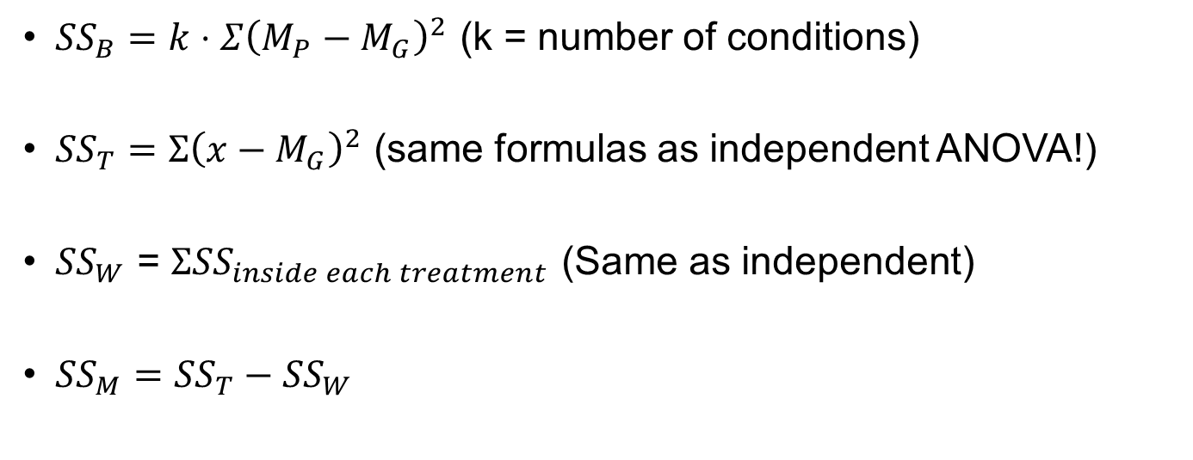
- SS_{R} = SS_{W} – SS_{B}

MS Formulas
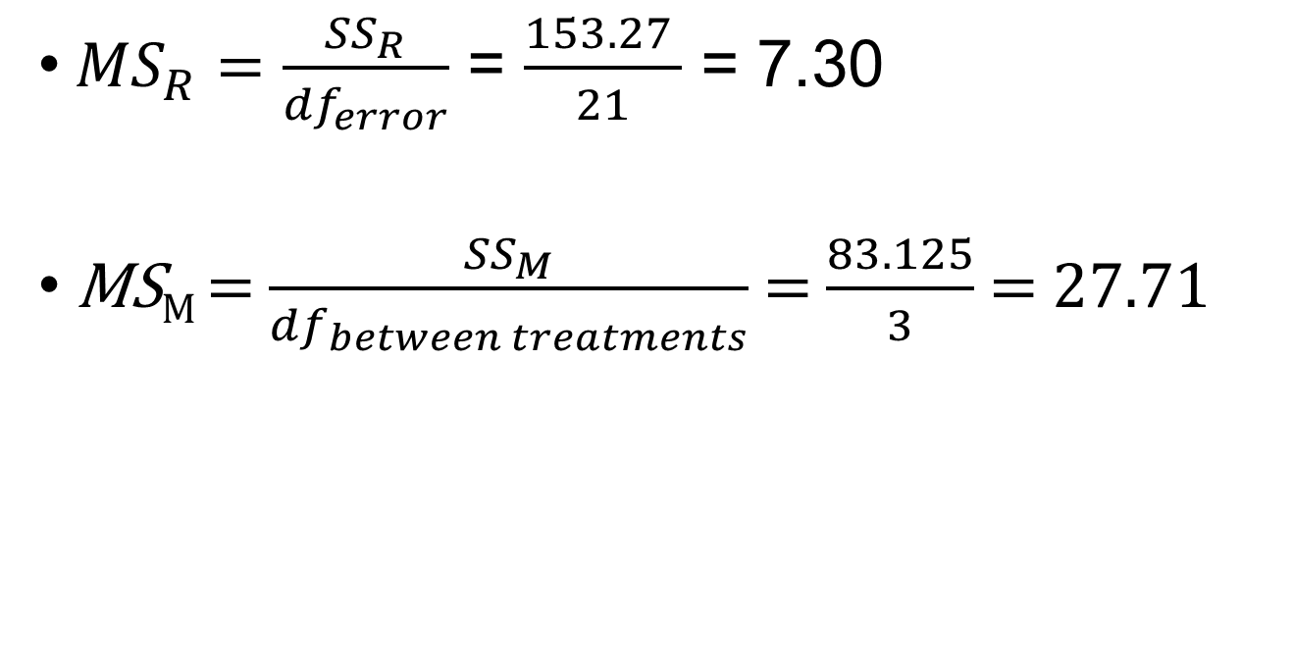
F formula
- MS_{M} / MS_{R}

